
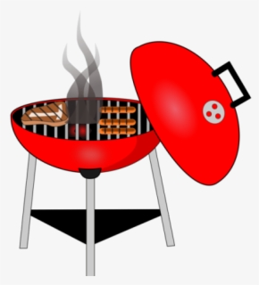
HOT DOGS
SALADS
DESSERT
BEVERAGES
$6.00

SUNDAY, MAY 12th
FOLLOWING THE SERVICE
SPRING BBQ
Everyone Welcome

